**BISWANATH COLLEGE**

**Year of Establishment:1960**

**(ANNUAL REPORT FOR THE PERIOD APRIL 2023 TO JULY 2024)**

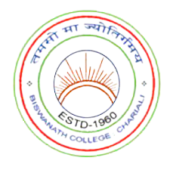

1. Address: College Road, Biswanath Chariali, Dist. Biswanath, PO Chariali, Assam, 784176
2. Website: [www.biswanathcollege.in](http://www.biswanathcollege.in)
3. College E-mail ID: [bcollege1960@gmail.com](mailto:bcollege1960@gmail.com)
4. Name of the Principal: Dr. Chinta Mani Sharma
5. Phone (i) Office (with STD Code): (03715) 222024 (ii) Mobile: 7002561613
6. Email ID of the Principal: cmsharma09@gmail.com
7. Type of Management: State Govt. Provincialised College.
8. Year of Provincialisation: 2006
9. Year of recognition of UGC Act, 1956 UnderSection 2 F Under Section 12B: 1964
10. Year of last NAAC accreditation: 2022 Grade / Points obtained: B with CGPA 2.19
11. Programmes offered:

|  |  |  |
| --- | --- | --- |
| Programmes | Year of first affiliation | Year of permanent affiliation |
| B.A | 1963-64 | 1963-64 |
| B.Sc | 1976-77 | 1976-77 |
| B.Com | 2012 |  |
| B.Voc. | — | — |
| BCA | 2018 |  |
| M.A. | 2018 |  |
| M.Sc | — | — |
| M.Com | — | — |
| Diploma | — | — |
| Certificate | — | — |
| Any other (please specify) | — | — |

1. New Academic Programmes introduced during **2023-24 : NIL** :
2. Student Enrolment during 2023-2024:

a) Under Graduate:

|  |  |  |  |  |  |  |  |  |  |  |  |  |  |  |  |  |  |  |  |  |
| --- | --- | --- | --- | --- | --- | --- | --- | --- | --- | --- | --- | --- | --- | --- | --- | --- | --- | --- | --- | --- |
| Programme | Semester | Intake capacity | Total admitted | | | SC | | | ST(P) | | | ST (H) | | | OBC/MOBC | | | PH | | |
| M | F | T | M | F | T | M | F | T | M | F | T | M | F | T | M | F | T |
| B.A. | 1stSem/ 2ndSem | 750 | 347 | 408 | 755 | 25 | 45 | 70 | 23 | 33 | 56 | 17 | 34 | 51 | 124 | 190 | 314 | 0 | 0 | 0 |
| 3rdSem/ 4th Sem. |  | 235 | 335 | 590 | 20 | 32 | 52 | 20 | 24 | 44 | 15 | 33 | 45 | 72 | 196 | 269 | 0 | 0 | 0 |
| 5th Sem./ 6th Sem. |  | 261 | 390 | 651 | 11 | 31 | 42 | 20 | 46 | 66 | 22 | 28 | 50 | 132 | 150 | 282 | 0 | 0 | 0 |
| **Total** | **750** | **843** | **1133** | **1996** | **56** | **108** | **164** | **63** | **103** | **166** | **54** | **95** | **146** | **328** | **536** | **865** | **0** | **0** | **0** |
| B.Sc. | 1stSem/ 2ndSem | 250 | 110 | 60 | 170 | 5 | 7 | 12 | 6 | 12 | 18 | 4 | 7 | 11 | 26 | 55 | 81 | 0 | 0 | 0 |
| 3rdSem/ 4th Sem. |  | 57 | 46 | 103 | 2 | 4 | 6 | 4 | 7 | 11 | 1 | 4 | 5 | 20 | 26 | 46 | 0 | 0 | 0 |
| 5th Sem./ 6th Sem. |  | 84 | 40 | 124 | 2 | 4 | 9 | 3 | 10 | 13 | 0 | 2 | 2 | 20 | 36 | 56 | 0 | 0 | 0 |
| Total | 250 | 251 | 146 | 397 | 9 | 15 | 27 | 13 | 29 | 42 | 5 | 13 | 18 | 66 | 117 | 183 | 0 | 0 | 0 |
| B.Com | 1stSem/ 2ndSem | 150 | 82 | 33 | 115 | 4 | 7 | 11 | 4 | 5 | 9 | 0 | 2 | 2 | 23 | 33 | 36 | 0 | 0 | 0 |
| 3rdSem/ 4th Sem. |  | 51 | 28 | 0 | 1 | 3 | 4 | 2 | 4 | 6 | 1 | 1 | 2 | 10 | 18 | 28 | 0 | 0 | 0 |
| 5th Sem./ 6th Sem. |  | 78 | 33 | 0 | 1 | 3 | 4 | 3 | 6 | 9 | 0 | 1 | 1 | 15 | 34 | 49 | 0 | 0 | 0 |
| Total | 150 | 211 | 94 | 115 | 6 | 13 | 19 | 9 | 15 | 24 | 1 | 4 | 5 | 48 | 85 | 113 | 0 | 0 | 0 |
| B.Voc. | 1stSem/ 2ndSem |  |  |  |  |  |  |  |  |  |  |  |  |  |  |  |  |  |  |  |
| 3rdSem/ 4th Sem. |  |  |  |  |  |  |  |  |  |  |  |  |  |  |  |  |  |  |  |
| 5th Sem./ 6th Sem. |  |  |  |  |  |  |  |  |  |  |  |  |  |  |  |  |  |  |  |
| Total |  |  |  |  |  |  |  |  |  |  |  |  |  |  |  |  |  |  |  |
| BCA | 1stSem/ 2ndSem | 40 | 30 | 6 | 36 | 3 | 0 | 3 | 2 | 0 | 2 | 0 | 1 | 1 | 9 | 5 | 14 | 0 | 0 | 0 |
| 3rdSem/ 4th Sem. |  | 21 | 1 | 22 | 0 | 0 | 0 | 1 | 2 | 3 | 0 | 0 | 0 | 2 | 5 | 7 | 0 | 0 | 0 |
| 5th Sem./ 6th Sem. |  | 19 | 1 | 20 | 0 | 0 | 0 | 0 | 0 | 0 | 0 | 0 | 0 | 10 | 1 | 11 |  |  |  |
| Total | 40 | 70 | 8 | 78 | 3 | 0 | 3 | 3 | 2 | 5 | 0 | 1 | 1 | 21 | 11 | 32 | 0 | 0 | 0 |
| Diploma  programme |  |  |  |  |  |  |  |  |  |  |  |  |  |  |  |  |  |  |  |  |
| Certificate programme |  |  |  |  |  |  |  |  |  |  |  |  |  |  |  |  |  |  |  |  |
| Other programmes  (Pl. Specify) |  |  |  |  |  |  |  |  |  |  |  |  |  |  |  |  |  |  |  |  |
| **Grand Total** | |  |  |  |  |  |  |  |  |  |  |  |  |  |  |  |  |  |  |  |

b) Post-Graduate (subject wise):

|  |  |  |  |  |  |  |  |  |  |  |  |  |  |  |  |  |  |  |  |  |
| --- | --- | --- | --- | --- | --- | --- | --- | --- | --- | --- | --- | --- | --- | --- | --- | --- | --- | --- | --- | --- |
| Subject (Assamese) | Sem. | Intake  Capacity | Total Admitted | | | S.C. | | | S.T(P) | | | S.T.(H) | | | OBC/ MOBC | | | P.H. | | |
|  | M | F | T | M | F | T | M | F | T | M | F | T | M | F | T | M | F | T |
|  | 1stSem/ 2ndSem | 20 | 1 | 7 | 8 | 0 | 0 | 0 | 0 | 0 | 0 | 0 | 0 | 0 | 1 | 7 | 8 | 0 | 0 | 0 |
| 3rdSem/ 4thSem |  | 4 | 5 | 9 | 0 | 0 | 0 | 0 | 0 | 0 | 0 | 0 | 0 | 0 | 4 | 4 | 0 | 0 | 0 |
| Total | **20** | **5** | **12** | **17** | **0** | **0** | **0** | **0** | **0** | **0** | **0** | **0** | **0** | **1** | **11** | **12** | **0** | **0** | **0** |
| PGDCA | 1stSem/ 2ndSem |  |  |  |  |  |  |  |  |  |  |  |  |  |  |  |  |  |  |  |

Final Examination Result (Regular Programmes only)

1. Appeared

|  |  |  |  |  |  |  |  |  |  |  |  |  |  |  |  |  |  |  |
| --- | --- | --- | --- | --- | --- | --- | --- | --- | --- | --- | --- | --- | --- | --- | --- | --- | --- | --- |
| Examination | Total Appeared | | | SC | | | ST(P) | | | ST(H) | | | OBC/ MOBC | | | PH | | |
| M | F | T | M | F | T | M | F | T | M | F | T | M | F | T | M | F | T |
| B.A. (General) | 102 | 132 | 234 | 12 | 7 | 29 | 5 | 9 | 14 | 9 | 14 | 23 | 32 | 40 | 72 |  |  |  |
| B.Sc. (General) | 20 | 9 | 29 | 0 | 1 | 1 | 3 | 2 | 5 | 4 | 1 | 5 | 5 | 4 | 9 |  |  |  |
| B.Com.(General) | 10 | 1 | 11 | 1 | 0 | 1 | 0 | 0 | 0 | 1 | 0 | 1 | 3 | 0 | 3 |  |  |  |
| PG (MA Assamese) | 4 | 5 | 9 | 0 | 0 | 0 | 0 | 0 | 0 | 0 | 0 | 0 | 0 | 4 | 4 |  |  |  |
| BCA | 11 | 1 | 12 | 1 | 0 | 1 | 2 | 0 | 2 | 0 | 0 | 0 | 5 | 1 | 6 |  |  |  |
| B.Voc. |  |  |  |  |  |  |  |  |  |  |  |  |  |  |  |  |  |  |
| Other Courses |  |  |  |  |  |  |  |  |  |  |  |  |  |  |  |  |  |  |

1. Passed

|  |  |  |  |  |  |  |  |  |  |  |  |  |  |  |  |  |  |  |
| --- | --- | --- | --- | --- | --- | --- | --- | --- | --- | --- | --- | --- | --- | --- | --- | --- | --- | --- |
| Examination | Total Passed | | | SC | | | ST (P) | | | ST(H) | | | OBC/ MOBC | | | PH | | |
| M | F | T | M | F | T | M | F | T | M | F | T | M | F | T | M | F | T |
| B.A. (General) | 68 | 112 | 180 | 8 | 8 | 16 | 3 | 6 | 9 | 5 | 13 | 18 | 30 | 44 | 74 |  |  |  |
| B.Sc. (General) | 14 | 8 | 22 | 0 | 0 | 0 | 1 | 2 | 3 | 5 | 1 | 6 | 4 | 3 | 7 |  |  |  |
| B.Com.(General) | 6 | 1 | 7 | 0 | 0 | 0 | 0 | 0 | 0 | 1 | 0 | 1 | 3 | 0 | 3 |  |  |  |
| PG (MA Assamese) | 0 | 2 | 2 | 0 | 0 | 0 | 0 | 0 | 0 | 0 | 0 | 0 | 0 | 0 | 0 |  |  |  |
| BCA | 11 | 1 | 12 | 1 | 0 | 1 | 2 | 0 | 2 | 0 | 0 | 0 | 5 | 1 | 6 |  |  |  |
| B.Voc. |  |  |  |  |  |  |  |  |  |  |  |  |  |  |  |  |  |  |
| Other Courses |  |  |  |  |  |  |  |  |  |  |  |  |  |  |  |  |  |  |

Final Examination Result (Under graduate Major Course/ HonoursProgramme- Subject wise).

1. Appeared

|  |  |  |  |  |  |  |  |  |  |  |  |  |  |  |  |  |  |  |
| --- | --- | --- | --- | --- | --- | --- | --- | --- | --- | --- | --- | --- | --- | --- | --- | --- | --- | --- |
| Major/ Honours subject | Total appeared | | | SC | | | ST (P) | | | ST(H) | | | OBC/ MOBC | | | PH | | |
| M | F | T | M | F | T | M | F | T | M | F | T | M | F | T | M | F | T |
| BA | 99 | 167 | 266 | 7 | 21 | 28 | 5 | 7 | 12 | 2 | 5 | 7 | 23 | 37 | 60 |  |  |  |
| BSc | 48 | 23 | 71 | 0 | 2 | 2 | 2 | 1 | 3 | 1 | 0 | 1 | 11 | 5 | 16 |  |  |  |
| BCom | 49 | 24 | 73 | 3 | 0 | 3 | 3 | 3 | 6 | 1 | 2 | 3 | 15 | 6 | 21 |  |  |  |
| BCA | **11** | **1** | **12** | 1 | 0 | 1 | 2 | 0 | 2 | 0 | 0 | 0 | 5 | 1 | 6 |  |  |  |
| Grand Total | 207 | 215 | 422 | 11 | 23 | 34 | 12 | 11 | 23 | 4 | 7 | 11 | 54 | 49 | 103 |  |  |  |

1. Passed

|  |  |  |  |  |  |  |  |  |  |  |  |  |  |  |  |  |  |  |  |  |  |  |
| --- | --- | --- | --- | --- | --- | --- | --- | --- | --- | --- | --- | --- | --- | --- | --- | --- | --- | --- | --- | --- | --- | --- |
| Major/ Honours subject | Total Passed | | | SC | | | | ST(P) | | | | ST(H) | | | | OBC/ MOBC | | | PH | | | |
| M | F | T | M | F | T | M | | F | T | M | | F | T | M | | F | T | | M | F | T | |
| BA | 84 | 158 | 242 | 5 | 22 | 27 | 4 | | 7 | 11 | 2 | | 5 | 7 | 20 | | 37 | 57 | |  |  |  | |
| BSc | 41 | 22 | 63 | 0 | 2 | 2 | 2 | | 1 | 3 | 0 | | 0 | 0 | 9 | | 5 | 14 | |  |  |  | |
| BCom | 43 | 22 | 65 | 1 | 0 | 1 | 3 | | 3 | 6 | 1 | | 2 | 3 | 15 | | 5 | 20 | |  |  |  | |
| BCA | **3** | **1** | **4** | 0 | 0 | 0 | 1 | | 0 | 1 | 0 | | 0 | 02 | 1 | | 3 |  | |  |  |  | |
| Grand Total | 171 | 203 | 374 | 6 | 24 | 30 | 10 | | 11 | 21 | 3 | | 7 | 12 | 45 | | 50 | 91 | |  |  |  | |

Final Examination Result(Post Graduate Programmes- Subject wise).

a) Appeared

|  |  |  |  |  |  |  |  |  |  |  |  |  |  |  |  |  |  |  |
| --- | --- | --- | --- | --- | --- | --- | --- | --- | --- | --- | --- | --- | --- | --- | --- | --- | --- | --- |
| Subject | Total appeared | | | SC | | | ST (P) | | | ST(H) | | | OBC/ MOBC | | | PH | | |
| M | F | T | M | F | T | M | F | T | M | F | T | M | F | T | M | F | T |
| Assamese (PG) | 2 | 6 | 8 | 0 | 0 | 0 | 0 | 0 | 0 | 0 | 0 | 0 | 2 | 6 | 8 | 0 | 0 | 0 |
|  |  |  |  |  |  |  |  |  |  |  |  |  |  |  |  |  |  |  |
| Grand Total | 2 | 6 | 8 | 0 | 0 | 0 | 0 | 0 | 0 | 0 | 0 | 0 | 2 | 6 | 8 | 0 | 0 | 0 |

b) Passed

|  |  |  |  |  |  |  |  |  |  |  |  |  |  |  |  |  |  |  |
| --- | --- | --- | --- | --- | --- | --- | --- | --- | --- | --- | --- | --- | --- | --- | --- | --- | --- | --- |
| Subject | Total Passed | | | SC | | | ST (P) | | | ST(H) | | | OBC/ MOBC | | | PH | | |
| M | F | T | M | F | T | M | F | T | M | F | T | M | F | T | M | F | T |
| Assamese (PG) | 1 | 1 | 2 | 0 | 0 | 0 | 0 | 0 | 0 | 0 | 0 | 0 | 1 | 1 | 2 | 0 | 0 | 0 |
|  |  |  |  |  |  |  |  |  |  |  |  |  |  |  |  |  |  |  |
| Grand Total | 1 | 1 | 2 | 0 | 0 | 0 | 0 | 0 | 0 | 0 | 0 | 0 | 1 | 1 | 2 | 0 | 0 | 0 |

Library facility as on 31-07-2024

|  |  |  |  |  |  |
| --- | --- | --- | --- | --- | --- |
| No. of Books | No. of Periodicals | No. of Manuscripts | No. of Journals | No. of E-journals | No. of library users during 2023-24 |
| 31561 | 04 | 0 | 2 | N-LIST | 13217 |

Detail of Teaching Staff as on 31-07-2024

|  |  |  |  |  |  |  |  |  |
| --- | --- | --- | --- | --- | --- | --- | --- | --- |
| Number of | | Total | Number of teachers with | | | | | |
| Assistant Professors | Associate Professors | Ph.D. | MPhil | NET | SLET | D.Lit | D.Sc |
| 44 | 10 | 54 | 24 | 22 | 8 | 17 | 0 | 0 |

**Computer and Internet facilities:**

a) Total number of Computers: 87 b) Number of computers with INFLIBNET- NLIST access: 20

c) Number of ICT enabled class room(s) / smart class room (s): 07

**Extra-curricular and Co-curricular activities**:

a) No. of N.C.C. Cadets: 92

b) No. of N.S.S. Volunteers: 82

c) No. of Scouts & Guides /Rovers /Rangers: Nil

d) Achievements/Awards of students in Regional/National events:

i) One NCC Cadet had Participated in the PM Ralley of Republic Day Camp Parade, 2024.

ii) One NCC Cadet had been adjudged as the best firer in the inter-unit Competition in September, 2023.

**Faculty development programmes organized by the college during 2023-24: NIL**

**Seminars/Workshop/Webinars conducted (2023-24):**

1. **Awareness drive against superstition was conducted at various vanues as given below,**

|  |  |  |
| --- | --- | --- |
| **Sl. No.** | **Date** | **Venue** |
| 1 | 06/05/2024 | Biswanath Girs’ H.S. School |
| 2 | 09/05/2024 | Biswanath H. S. School |
| 3 | 11/05/2024 | Chariali academy H. S. School |
| 4 | 13/05/2024 | Street play at Biswanath town |
| 5 | 14/05/2024 | D.L.M. High School |
| 6 | 15/05/2024 | Street play at Pavoi H. H. School |
| 7 | 16/05/2024 | Bapuji High School |
| 8 | 17/05/2024 | Street play at Baghmari centre |
| 9 | 18/05/2024 | Satsang High School |
| 10 | 20/05/2024 | Chariali Adarsha Vidyapeeth |
| 11 | 22/05/2024 | Kamalakanta smriti M. E. School |
| 12 | 25/05/2024 | Nilpur T. G. L.P. School |
| 13 | 28/05/2024 | Chariali H.S. & M.P. School |

1. Eco-Club, Biswanath College organised a two days long workshop on “Vermicomposting” and “Solid Waste Management” from 05-06-2024 to 06-06-2024. The workshop was catalysed by IQAC and IIC, Biswanath College; sponsored by Assam Science Technology and Environment Council (ASTEC) and supported by Ministry of Environment, Forest and Climate Change, Govt. of India keeping in view Mission LiFE in Assam.
2. IIC Biswanath College had organised an one day workshop on innovation and entrepreneurship on 16th May 2024.
3. An interaction programme with Rashtriya Raksha University, Pasighat was organised on 7th May, 2024.
4. One recruitment drive for UG students was organised on 9th January, 2024 in collaboration with TATA Electronics.
5. A one day seminar was organised on “Awareness on AIDS” on 1st December, 2023.
6. One day workshop on FYUGP curriculum of Gauhati University was conducted on 26th April, 2024. Prof. Madhurjya P Bora of Gauhati University was the resource person of the Workshop.
7. A one day seminar was organised on 20th June, 2024 on Preparedness of Educational Institutes for Implementation of NEP 2020 in collaboration with Girijananda Choudhury University. Prof. Alak Kumar Buragohain, Chancellor, Girijananda Choudhury University and Prof. Kandarpa Das, Vice Chancellor of girijananda University were the esteemed resource person for the programme.

**Research Projects(2023-24):**

a. Completed: Nil

b. Ongoing:

ASTEC funded minor project on “Extraction and formulation of Perfume from essential oil of Dioscorea species of N.E. India” for a duration of 2 years (2022-2023) at a sanctioned amount of Rs. 400000 INR sanctioned to **Dr. Nilofer Sheikh**, Dept. of Botany, Biswanath College.

**Academic activities**:

1. **Publication of research papers in peer reviewed/UGC care list journals during 2023-24.**
2. **P. Sabhapandit and colleagues. 2023. Some specific weak V-algebras.** *Nonlinear Studies (Scopus indexed)*, 30(2), 445-449. (ISSN 1359-8678).
3. **P. Sabhapandit and colleagues. 2024. On Multiplier and Reversal Maps on BCK/BCI-algebras**. *Jnanabha (UGC-care)*, 54(1), 224-229. (ISSN 2455-7463(online)).
4. **Indira Sarma, and collegues. 2023. Female Reproductive Health - Regulating Hormones and Phytosteroids as Alternative Modulator: A Review**. *Annals of Multidisciplinary Research, Innovation and Technology (AMRIT)*, 2(1), 2023, 45-53. (IF 1.5)
5. **Publication of Chapter(s) in Books during 2023-24 (only those considered for API Score).**
6. Happy Deuri published a book chapter entitle Women empowerment through political participation in the edited book Women empowerment and inspiring journey,   
   ISBN No-978-81-971439, 2023.
7. Tamasing Brahma published a book chapter entitled Role of Bodo Women in Mainao Borainai Festival: Revisiting Sociology-Political Challenges Against Women. Edited by Dr. A. F. Md Malik & Dr. C. Das, published by Sunbeam, Rupnagar, Guwahati-32, ISBN 978-93-93092-55-7, 2023.
8. Tamasing Brahma published a book chapter entitled A Study on Domestic Violence in the Short Story ‘Daia Swrni’ by Nilkamal Brahma: Human Rights and Subaltern Groups vol.II. Edited by Dr. A.F. Md Malik & Dr. C. Das, published by Sunbeam, Rupnagar, Guwahati-32, ISBN 978-93-93092-99-1. 2024.
9. Sibasree Hojaisa published a book chapter title Databases and Tools for Microbial Genome and Human Microbiome Studies in In: Verma, P. (eds) Industrial Microbiology and Biotechnology. Springer, Singapore <https://doi.org/10.1007/978-981-99-2816-3_3> , Print ISBN  
   978-981-99-2815-6, Online ISBN 978-981-99-2816-3, 2024.
10. **Publication of Books during 2023-24 (only those considered for API Score).**
11. Dr. Karabi Gogoi and Ashomi Kalita published a book entitled Economic Development and Policy in India-II published by B.D. Prakash, Panbazar, Guwahati-1. ISBN 978-93-94134-12-6
12. Dr. Karabi Gogoi published a book jointly with Alaka Hujuri, Ashomi Kalita and Pragati Kanu entitled Basic Elements of Economics, published by Kalyani, Guwahati Branch. ISBN 978-93-5540-934-8

d**) Details of Books and Journals published by the College during 2023-24:** NIL

1. **Details of papers presented by the teachers during 2023-24:**
2. Bandana Gogoi presented a paper on *"Socio-economic dimension of Hindu Temples of Biswanath "* in the 42nd session of North East India History Association at Assam University, Diphu Campus, from 23 to 25 November 2023.
3. Bandana Gogoi presented a paper on *"Roles of Temples in promoting tourism at Biswanath "* in National Seminar on Cultural Heritage of the North Eastern Region for Self Reliant India:Challenges and Opportunities organized by Department of History, Nowgong Colleges Autonomous from 3 to 4 November 2023.
4. Happy Deuri presented a paper on *“The ethnic women as emerging leader in tribal identity politics:A study of Deori autonomy movement and autonomous council”* in UGC sponsored National Seminar organized by Tezpur college from 18 to 19 March 2024.
5. Geeti Gogoi presented a paper on *"Thermal radiation and magnetic field induced flow of Cuo/H20 Nanofluid through an inclined channel: Entropy generation analysis"* in the International Conference on Pure and Applied Mathematics (ICPAM-2023) organized by Department of Mathematics, NIT Jalandhar & MNIT Jaipur from 26 to 28 October 2023.
6. Tamasing Brahma presented a paper on *“Borophwrni Agor Akhai Ernaiao Berkhangnai Ecologyni Makhase Bithingphwr”* in the ICSSR, New Delhi Sponsored Two Day National Seminar on Folklore and Ecology of North East India organised by the Department of Bodo Gauhati University from 8 to 9 February 2024.
7. Indira Sarma presented a paper on *"Phytoconstituents of Scoparia dulcis induces alteration of expression in mice uterus during periimplantation period of gestation in mice"* in ICSSR sponsored International Conference on Traditional Knowledge (Exploring Traditional knowledge : Bridging past and Future) from 22 to 23 March 2024 at Nagaon College (Autonomous).
8. Sibasree Hojaisa present a paper on *“Computational Exploration of   
   Hydroxycinnamic acid Binding to Hen Egg White Lysozyme for Potential Therapeutic Applications: Insights from Molecular Docking and Molecular Dynamics Simulations”* at the Eleventh International Conference on Fermented Foods, Health Status and Social Well-being, being organized at NEHU, Shillong (Meghalaya, India) by NEHU, Tura Campus, Meghalaya & Swedish South Asian Network on Fermented Foods (SASNET-FF) in collaboration with many reputed organizations from 21 to 22 November, 2023
9. Pratikshya Bezbaruah presented a paper on *"A review on interaction mechanism in complex plasma with and without dissipative effects due to ion neutral collision"* in the International conference on Frontiers in Pure and Applied Physics(ICFPAP-2024) organized by USTM in collaboration with Physics Academy of North East from 29 February to 2 March 2024.
10. Nabanita Sarmah presented a paper on *"Holistic and Multidisciplinary Approach in Higher education in Assam : In the light of NEP 2020"* in 28 th NEIES conference in 2024 organized by Department of Education, Gauhati University in collaboration with GUCDOE and West Gauhati college of Education from 4 to 5 April , 2024.
11. Debashis Sarmah presented a paper on *“ Metamaterial Based Microwave Absorber (MMA) for Electromagnetic Interference (EMI) Shielding Designed for X-Bannd Applications”* in DST-SERB sponsored International Conference on Devices, Sensors and Systems (CoDSS) organized by the Department of Electronics and Communication Engineering, Tezpur University, Assam from 10 to 11 February, 2024.

e) **Refresher Course/Orientation Course/Short Term Course/Faculty Development Programme/Faculty Induction Programme attended by the teachers during the 2023-24:**

1. Bandana Gogoi attended FDP on Research Method and Research Design organised by Ramanujan College, University of Delhi from 30 to 06 December 2023.
2. Geeti Gogoi attended a FDP on "Scientific Language" organized by Department of Mathematics, School of Basic Sciences, The Assam Kaziranga University, Jorhat, Assam, India from 26 April to 2 May, 2023.
3. Geeti Gogoi attended a Professional Development Programme on ‘Implementation of NEP­2020 for University and College Teachers’ organized by INDIRA GANDHI NATIONAL OPEN UNIVERSITY Staff Training and Research Institute of Distance Education New Delhi 110068 from 12 to 20 June 2023.
4. Geeti Gogoi attended a FACULTY INDUCTION PROGRAMME organized by UNIVERSITY GRANTS COMMISSION,MALAVIYA MISSION TEACHER TRAINING CENTRE, MIZORAM UNIVERSITY from 14 November to 11 December, 2023.
5. Tamasing Brahma attended a Faculty Development Program on Advance Tools and Techniques for Research Methodology organised by Research Foundation of India & RFI-CARE, from 3 to 12 June, 2024.
6. Tamasing Brahma attended a Faculty Development Program on Research Paper Writing organised by Research Foundation India & Council of Academic Research and Educational Organisation, from 1 to 8 July, 2024.
7. Indira Sarma attended a Faculty Induction Programme (FIP) (4 weeks) organized by TLC Ramanujan College and AIE (under the aegis of Ministry of Education PMMMNMT), from 23 May -21 June 2023.
8. Pratikshya Bezbaruah attended a Refresher Course organized by TLC, Ramanujan College, University of Delhi from 9 to 23 June 2023.
9. Pratikshya Bezbaruah has participated in the National Workshop on Quantum Physics (Alice in Quantumland) organized by Kanya Mahavidyalaya, Jalandhar in association with IAPT from 9 to 14 April 2024.
10. Debashis Sarmah attended a Refresher Course organized by TLC, Ramanujan College, University of Delhi from 9 to 23 June 2023.

**Awards/Fellowship received by the teachers (2023-24): NIL**

**Patents (2023-24): NIL**

**Teachers Visited abroad during 2023-24**: 01

**Hostel facilities**: No. of Boys Hostel: 01 Total Seats: 18

No. of Girls Hostel: 02 Total seats: 96

|  |  |
| --- | --- |
| Sports facilities: | Play ground, Indoor Stadium, Gymnasium |
| Auditorium/ Seminar/Conference Room: | Conference Room: 2, Seminar Hall : 2 |
| Specialized laboratory/ studio/ facility: | 1 No Language Laboratory . |
| Augmentation of infrastructural facilities during the period 2023-2024: | Development of internal roads within the campus. Two classrooms and departmental teachers’ common room for the Department of Commerce had been constructed. |
| Technology up gradation during the period 22023-2024: | We have extended Wifi coverage within the campus by installing Wifi routers in twoi more academic departments, Lecture Hall and Auditorium. |
| Financial aid to students during the period 2023-2024: | Fee waiver has been provided to nearly 85% students undefr Pragyan Bharti Scheme of Govt. of Assam. |
| Activities of the student counseling and Guidance Cell during the period (in brief) | Five number of counseling sessions were conducted during this period. |
| Placement of students (in brief): | 40 students who had passed out from our college got placement in various government sectors. |
| Activities of Alumni Association during 2023-2024: | Cooperated in various Celibrations in the College specifically the College Foundation Day on 7th September, 2023. |
| Community Outreach Programme during 2023-2024: | Various street plays were organised, awareness programmes, departmental extension activities were held during this period. |
| Any other relevant information: | Construction of two open stages are under progress. |

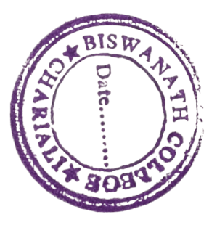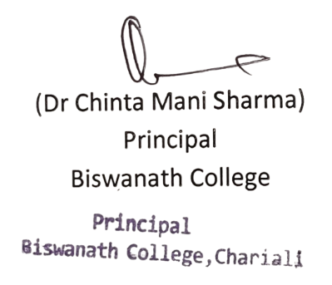

**Best high resolution photographs of any activity/event/infrastructural facility of the college during the year 2022-23.**

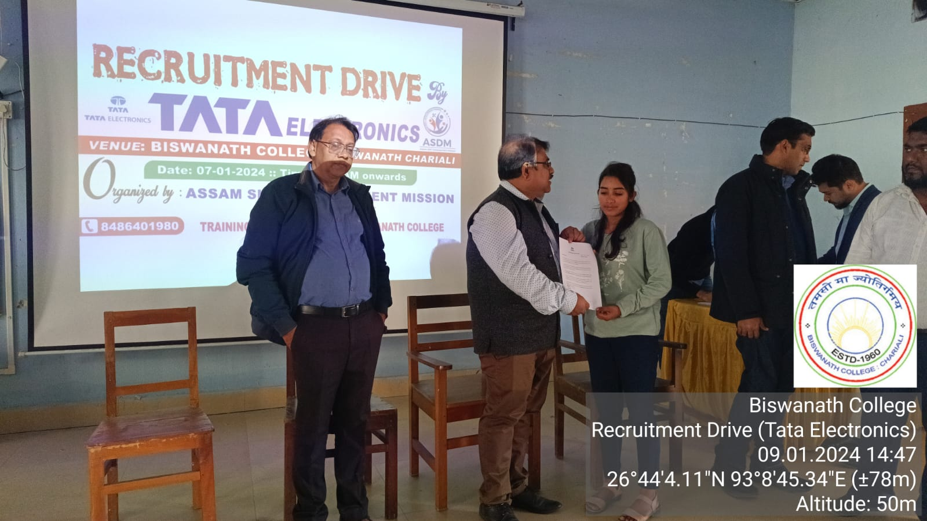

**A recruitment drive in collaboration with TATA Electronics was organized on 9th January, 2024**

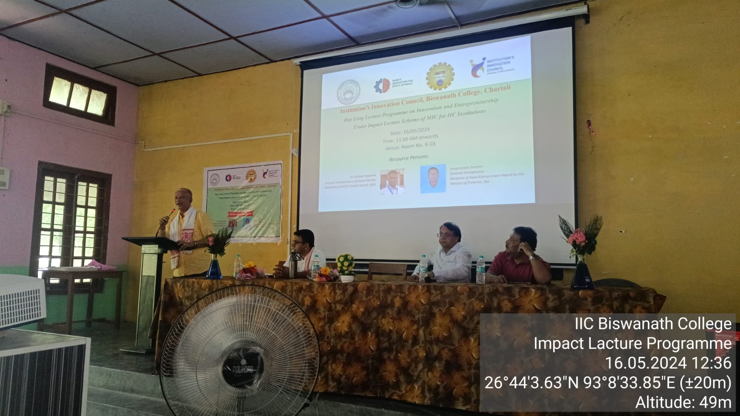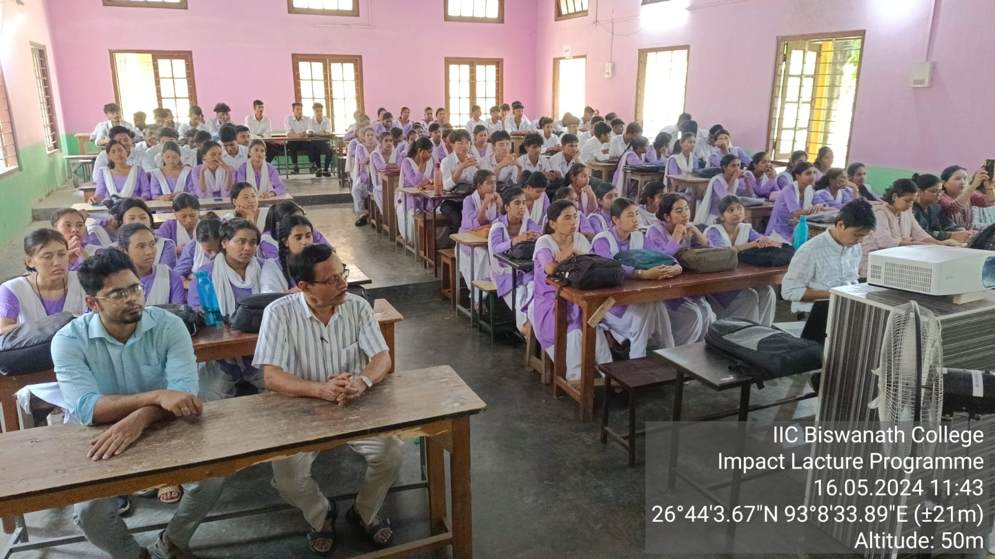

**A one day Workshop on Innovation and Entrepreneurship was organized by IIC Biswanath College on 16th May, 2024**

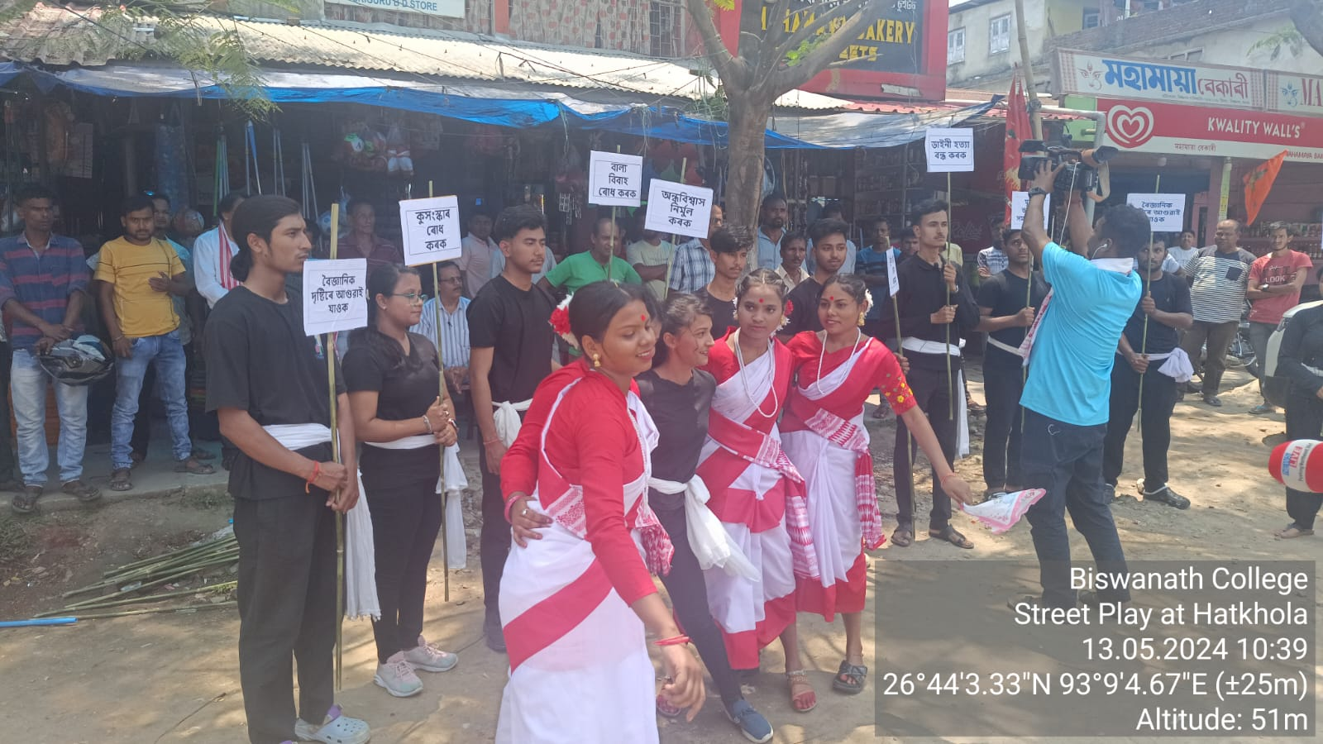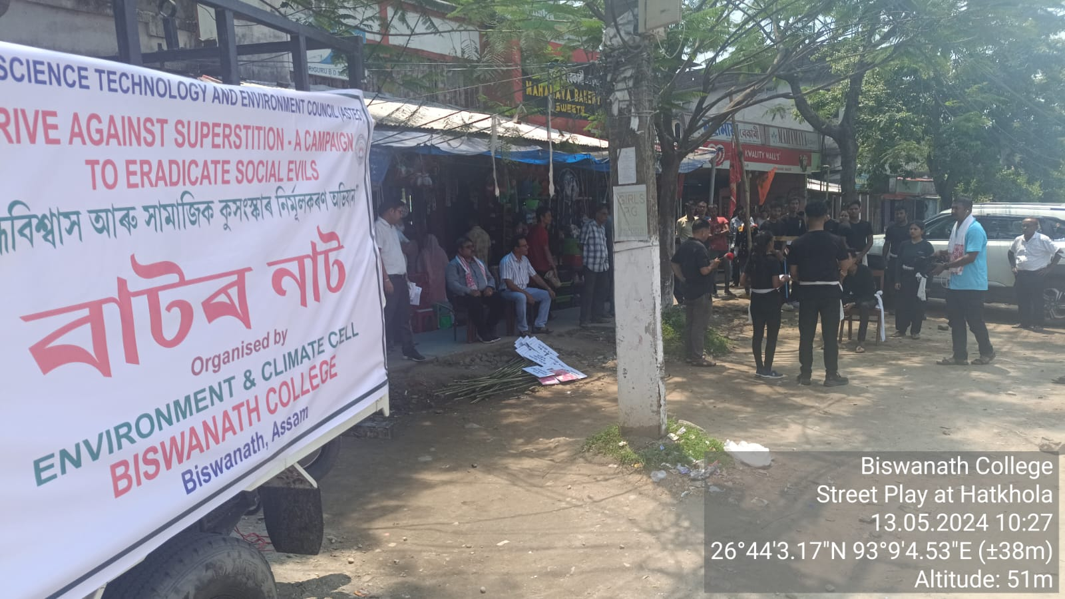

**Streetplays were conducted as part of Drive against Superstition at various public gathering places in and around Biswanath Chariali were organized in month of May, 2024 by Environment and Climate Cell, Biswanath College.**

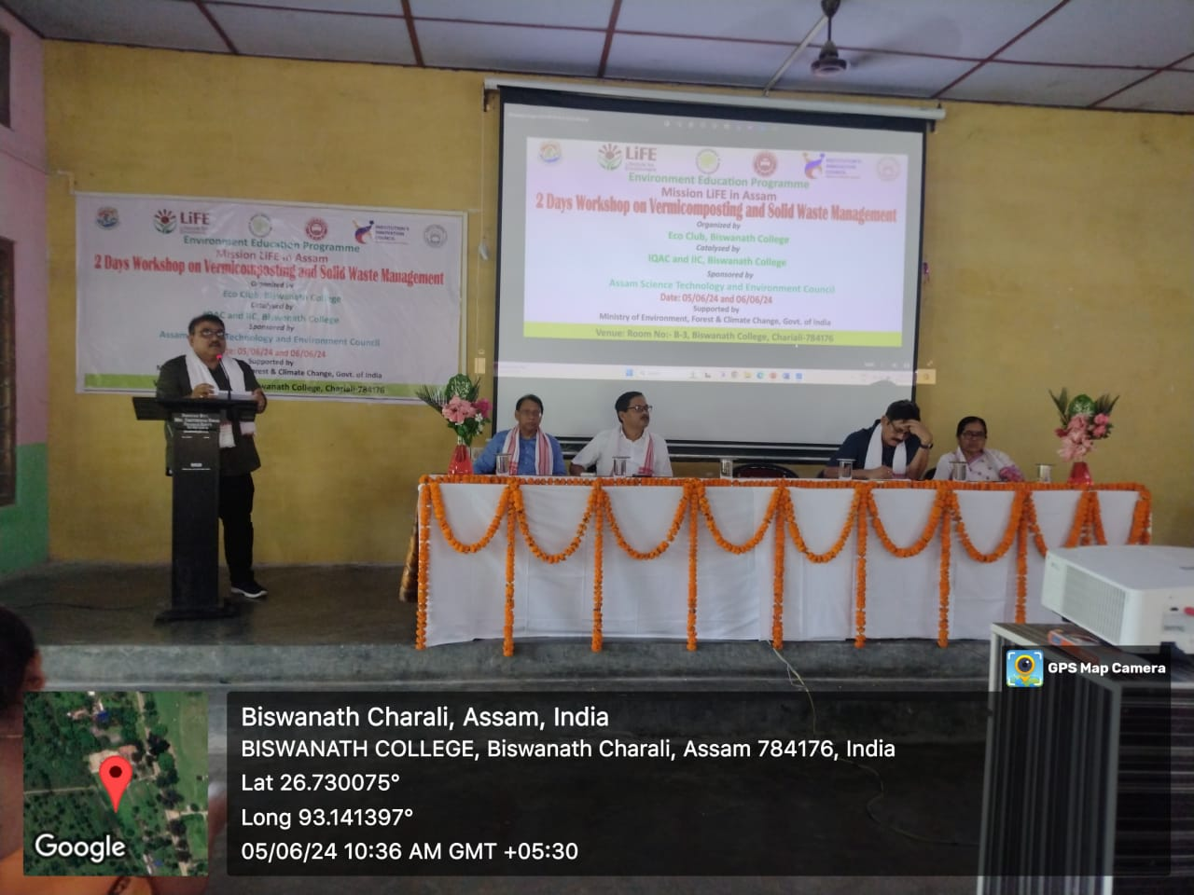

**Two day workshop on Vermicomposting and Solid Waste Management was organized by IQAC and IIC Biswanath College from 5th June to 6th June, 2024**

