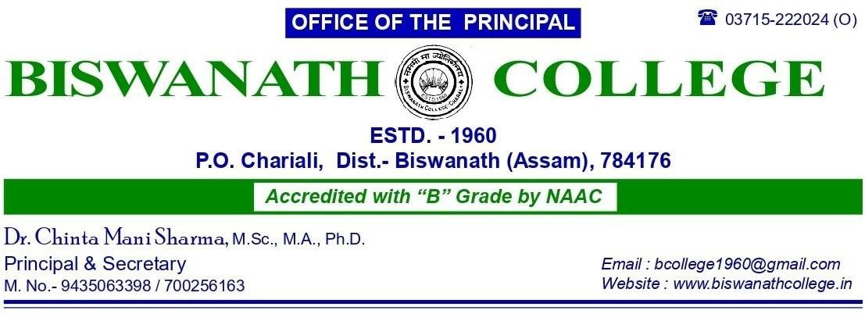
Memo No : ........................................ Date :...........28.04.2026

ADMISSION NOTICE

The following applicants are provisionally selected for admission in to Higher Secondary First Year (Science) for the Session 2026-27. Their final admission is subject to physical verification of their original documents. College reserves the right to cancel their candidature if they can’t produce any documents or find any discrepancy on their documents. They are instructed to bring the original and photocopies of the following documents on the date of admission for physical verification-

1. Passport size photo.
2. HSLC Admit Card and Registration Certificate.
3. HSLC Marksheet and Pass Certificate.
4. Caste Certificate (if applicable).
5. Students must bring Aadhar Card, APAAR ID, and PEN number from the previous institute.
6. Income certificate/ Ration card of parents/ BPL Card for availing fee waiver.
7. Print out of application form (DARPAN portal).
8. Front page of Passbook of the applicant.
9. Gap Certificate (If applicable).

Unreserved (Merit)
Sl No | Name | Percentage | Category | Extra Curricular | Specially Abled
1 | PRABHAKAR DULAL | 83.67 | GENERAL | NO | NO
2 | RAHUL SHARMA | 83.5 | GENERAL | NO | NO
3 | SWAGAT BHARALI | 83.17 | SC | NO | NO
4 | NAYAN RAJ NATH | 83.17 | OBC | NO | NO
5 | RUPJYOTI NATH | 82.5 | OBC | NO | NO
6 | GOURAV DHAMALA | 82.33 | GENERAL | NO | NO
7 | ANKITA DEVI | 79.6 | OBC | NO | NO
8 | PRACHURYA PAUL | 78.83 | OBC | NO | NO
9 | JIBON RAUT | 77 | OBC | NO | NO
10 | BISHAL TAMANG | 75.67 | OBC | NO | NO
11 | BIDYASHREE DAS | 75.5 | SC | NO | NO
12 | GANESH RAI | 75.5 | OBC | NO | NO
13 | IMONI PEGU | 75.17 | ST(P) | NO | NO
14 | KOUSTAV MONI HANDIQUE | 74.8 | OBC | NO | NO
15 | KANKANA BHUYAN | 74.17 | GENERAL | NO | NO
16 | BISWAJIT TOKBI | 73.67 | ST(P) | NO | NO
17 | DRISTINANDA KALITA | 73.4 | GENERAL | NO | NO
18 | UDDAYAN HAZARIKA | 73.33 | GENERAL | NO | NO
19 | PRITAM BHOMIK | 73 | OBC | NO | NO
20 | MAHHIMA THAKUR | 73 | OBC | NO | NO
21 | KRISHNAMONI KHEROWAR | 73 | OBC | NO | NO
22 | PRIT KUMAR | 71.83 | OBC | NO | NO
23 | PRITY BANIA | 71.83 | SC | NO | NO
24 | HANGAMA BASUMATARY | 71.5 | ST(P) | NO | NO
25 | MONISHA BASUMATARY | 71.33 | ST(P) | NO | NO
26 | GAURAV BASUMATARY | 70.17 | ST(P) | NO | NO
27 | ABDUL MANNAN | 70 | GENERAL | NO | NO
28 | JERIFRAJ AHMED | 69.5 | GENERAL | NO | NO
29 | ANKIT SURIN | 69.5 | OBC | NO | NO
30 | NIBIR BORAH | 69 | GENERAL | NO | NO
31 | KRISHNAJUN TERON | 68.4 | ST(H) | NO | NO
32 | MD SAHBAJ ANSARI | 67.67 | OBC | NO | NO
33 | PARASHA RANI BARUAH | 67.33 | OBC | NO | NO
34 | PURNIMA DEVI | 67.17 | GENERAL | NO | NO
35 | MANASH PRATIM BHAGABATI | 66.33 | GENERAL | NO | NO
36 | DIBAKAR KEOT | 66.17 | OBC | NO | NO

OBC (Merit)
Sl No | Name | Percentage | Category | Extra Curricular | Specially Abled
1 | ROUNAK MUKTAN | 65.83 | OBC | NO | NO
2 | GAGAN CHETRY | 65.2 | OBC | NO | NO
3 | RAJ PRASAD | 64.67 | OBC | NO | NO
4 | HEEMA GUPTA | 63.5 | OBC | NO | NO
5 | ARCHINA DEEP | 62.83 | OBC | NO | NO
6 | LUNA KANDHA | 62.67 | OBC | NO | NO
7 | PANKI KOCH | 62 | OBC | NO | NO
8 | SOURYA KASHYAP SAHU | 61.8 | OBC | NO | NO
9 | MOHESH MAJHI | 61.17 | OBC | NO | NO
10 | KRISHNA NATH | 61 | OBC | NO | NO
11 | RAJKISHOR TANTI | 60.83 | OBC | NO | NO
12 | ALOK CHETRY | 60.67 | OBC | NO | NO
13 | ADESH KANU | 60.33 | OBC | NO | NO
14 | NAYANJYOTI CHUTIA | 60.17 | OBC | YES | NO
15 | ASHMA GURUNG | 60 | OBC | NO | NO
16 | ANKITA SHAH | 59.33 | OBC | NO | NO
17 | NELSON PURTY | 57.5 | OBC | NO | NO
18 | DIPIKA TOSSA | 57.5 | OBC | NO | NO
19 | SUSHMITA BAKTI | 57 | OBC | NO | NO
20 | ANKITA KONDAPAN | 54.83 | OBC | NO | NO

SC (Merit)
Sl No | Name | Percentage | Category | Extra Curricular | Specially Abled
1 | MAYUR DAS | 64.67 | SC | NO | NO
2 | AJITA DAS | 47 | SC | NO | NO

ST-H (Merit)
Sl No | Name | Percentage | Category | Extra Curricular | Specially Abled
1 | GAYANTRI TERANGPI | 58.17 | ST(H) | NO | NO
2 | CHARLI TOKBI | 53.33 | ST(H) | NO | NO
3 | JOYA TIMUNGPI | 51.5 | ST(H) | NO | NO
4 | NIHANG TERON | 49.67 | ST(H) | NO | NO

ST-P (Merit)
Sl No | Name | Percentage | Category | Extra Curricular | Specially Abled
1 | SUN KUMAR NARZARY | 65.17 | ST(P) | NO | NO
2 | IMMANUEL DOLEY | 65 | ST(P) | NO | NO
3 | SOSHI KR PEGU | 62.67 | ST(P) | NO | NO
4 | ROKTIM MADHAB DEORI | 59.33 | ST(P) | NO | NO
5 | SANIYA BASUMATARY | 58.83 | ST(P) | NO | NO
6 | DHWRWMSA DAIMARY | 57.5 | ST(P) | NO | NO
7 | RAJA TAYENG | 56.67 | ST(P) | NO | NO

Extra Curricular (Merit)
Sl No | Name | Percentage | Category | Extra Curricular | Specially Abled
1 | NIDHA NAZ | 61.67 | GENERAL | YES | NO




